# Crowdfunding Preparation for Sfaira

## Comparing Crowdfunding Websites

|  |  |  |  |
| --- | --- | --- | --- |
| **Platform** | **Fees (Platform+Processing)** | **Reach** | **Fit for Sfaira** |
| **Kickstarter** | 5% of total funds raised. | Global Audience | Fits |
| **Indiegogo** | 5%: of total funds raised | Global Audience | Fits |
| Ulule | The Ulule commission of 8%. | Focused more on Europe | - It’s not as strong as Kickstarter & Indiegogo  - Less audience we can reach  + All of the theatre related projects are more or less getting funded |
| **Produzionidalbasso** | 5% of total funds raised. | Italian Based | + Italian Based  - Less audience we can reach |
| Eppela | The platform does not charge a fixed percentage as service fees. It applies a flat fee related to transaction management costs equal to 2.90% of the total raised + €0.25 for each transaction. | Italian Based | Same pros and cons as Ulule |

**About the Equity Crowdfunding Websites**: I don’t think it is feasible to use the Equity crowding websites at this stage of the crowdfunding, it would be surplus for us to find angel investors but in these websites it is even more harder to find an investor who is willing to invest in theatre projects because majority of the campaigns are consist of technological projects and our project might get lost in those projects.

Perks

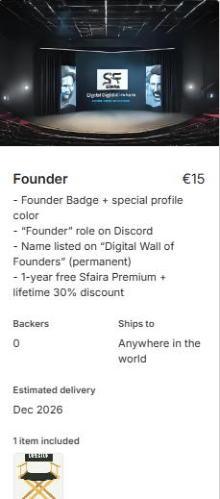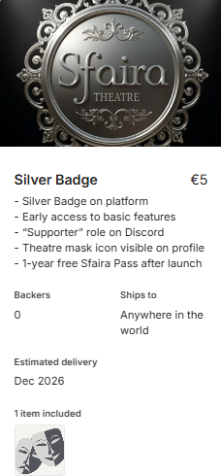 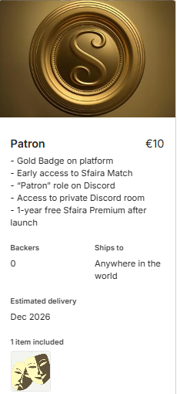

### Drafting the Campaign Page Content

#### Title & Slogan

**Sfaira:** The world’s first digital theatre platform where you can watch, feel, and connect. Join us to bring Italian theatre to a global stage.

#### Introduction / Story of the Sfaira

What is Sfaira?

Sfaira is a digital platform at the intersection of culture, technology, and social connection. Designed as a dedicated streaming service for theatre, Sfaira offers users access to accurate library of performances from classical masterpieces to contemporary productions supported by two unique features: Virtual Cinema Rooms & Sfaira Match, a social matching tool for theatre lovers.

Our Mission

The goal is to create an immersive and interactive digital environment where users can watch live and on-demand content, feel the emotional depth of theatre, and connect with others who share their passion, whether for friendship, conversation, or romantic connection.

“Theatre has always connected hearts, but today many people cannot access it. Sfaira brings theatre to your home, making it timeless, borderless, and interactive.”

#### A screen shot of a computer AI-generated content may be incorrect. Features that make Sfaira unique

🎭 On-demand Theatre Streaming

- A curated digital archive of theatre, classical to

contemporary, available anytime, anywhere.

🖥️ Virtual Cinema Rooms (Sfaira Salon)

- A co-viewing feature where users can watch performances together in real time, chat, and experience the show as a group

💬 Sfaira Match (social connection)

- a social matching tool for theatre lovers.

🌍 Creator Support & Collaboration

- A platform that supports and funds creators, giving them space to distribute their work globally and engage directly with a new generation of fans.

#### Roadmap (Progress & Features)

With 80% of our platform already developed, Sfaira is a tangible reality, not just a concept. We have built the core infrastructure, evaluated early features like the Virtual Cinema and Sfaira Match, and begun conversations with theatre creators and schools in Italy.

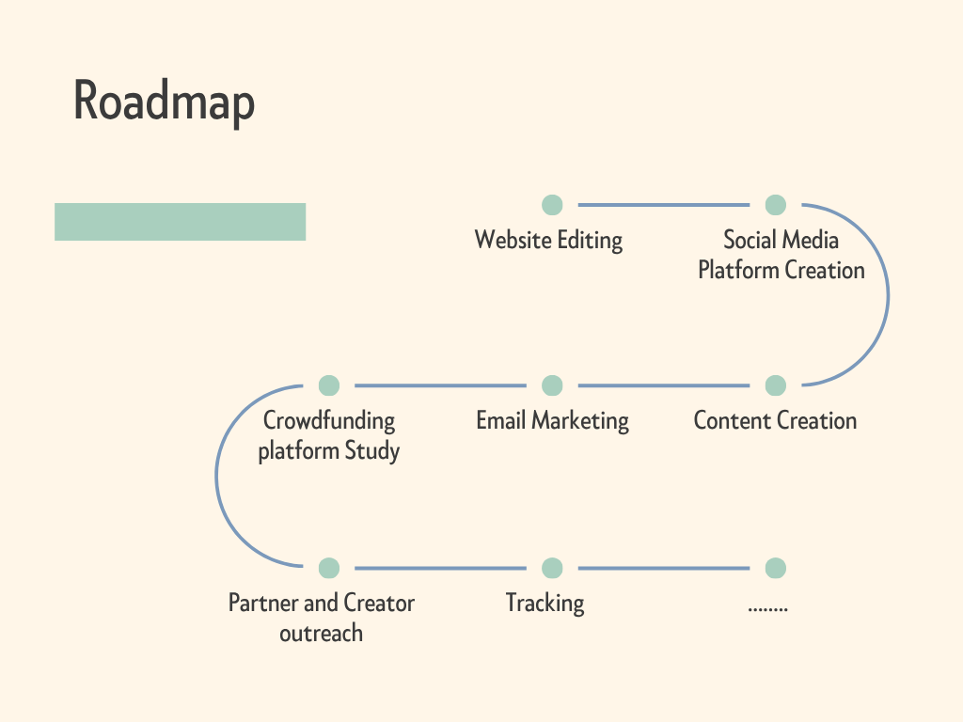

#### What We Need & What You Get

**We’re raising €25,000** to outfit the platform with key features that will allow us to hit the ground running.

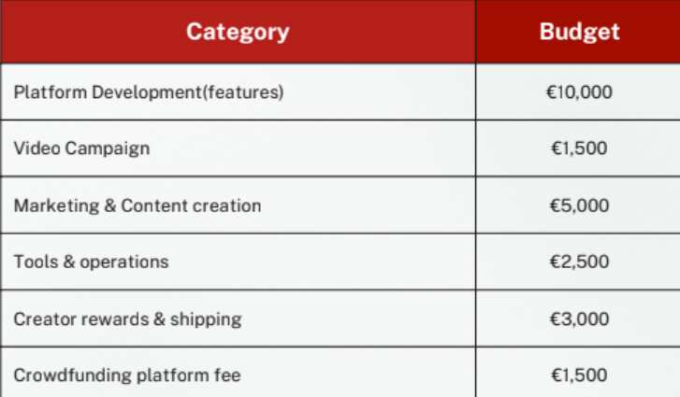

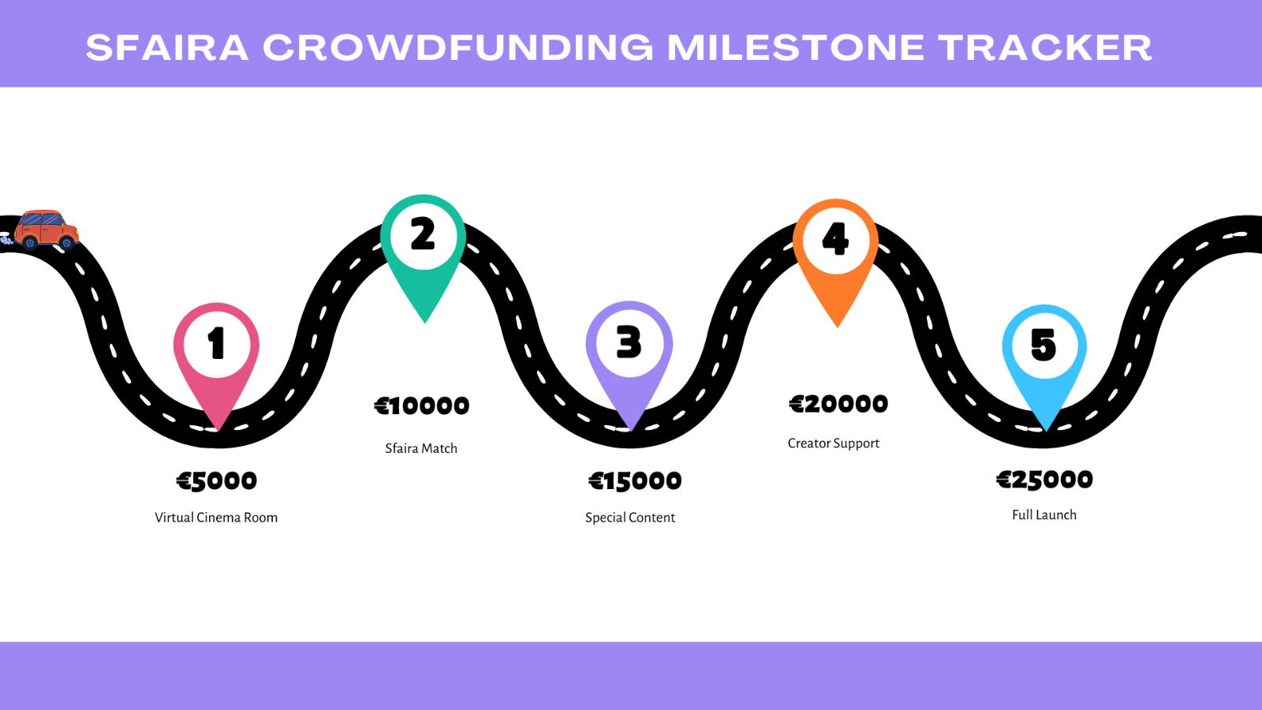

Other Ways You Can Support

If you'd like to help in another way, please consider **sharing this campaign with your networks, on social media, or directly with friends and fellow artists**. Every post and every mention help us reach new people and bring this dream to life.

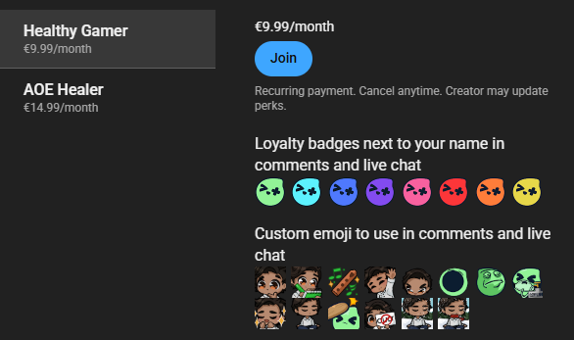Tier Based Badge System

Tier 1: €4.99 – “Supporter Badge”

-Silver Badge

-Early access to basic platform features

-Basic theatre mask icon on the platform

- “Supporter” Role on Discord

Tier 2: €9.99 – “Patron Badge”

-Gold Badge

-Early access to Sfaira Match

- “Patron” role on Discord

 -Access to the private room on Discord

Tier 3: €14.99 – “Founder Badge”

- “Founder” role on Discord

-Special color for the name on the platform

**Note:** This badge system is inspired by Youtube’s join feature. This is an early donation-based system, and it is different from the “Rewards for Investors: Investing in the Future of Theatre.”. in the document Sfaira: The Digital Stage for Italian Theatre.

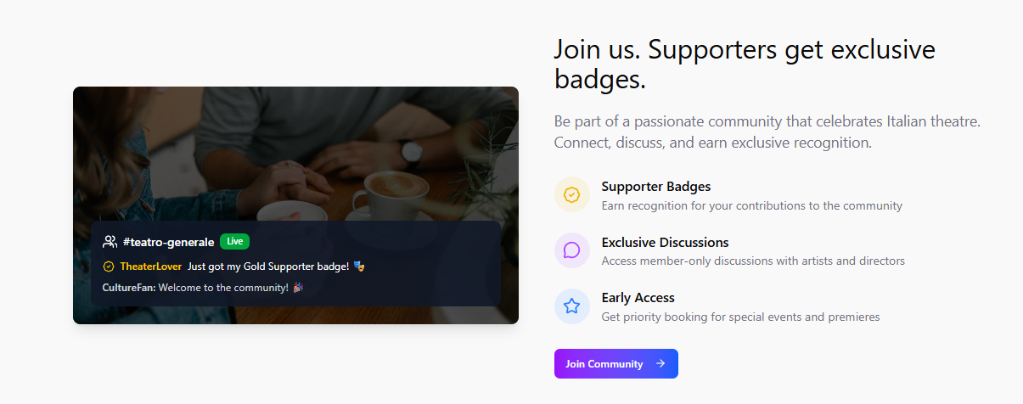

|  |  |  |  |
| --- | --- | --- | --- |
| **Model** | **Tier** | **Price** | **Perks / Features** |
| **Crowdfunding (Donation-Based)** | **Supporter Badge** | €4.99 (one-time) | A pair of masks with a black background  AI-generated content may be incorrect. Silver Badge on platform |
| 🎟 Early access to basic features |
| 😃 “Supporter” role on Discord |
| 🎭 Theatre mask icon visible on profile |
| + **1-year free Sfaira Pass after launch** |
|  | **Patron Badge** | €9.99 (one-time) | A pair of masks with shadows  AI-generated content may be incorrect. Gold Badge on platform |
| 💬 Early access to Sfaira Match |
| 👑 “Patron” role on Discord |
| 🔒 Access to private Discord room |
| + **1-year free Sfaira Premium after launch** |
|  | **Founder Badge** | €14.99 (one-time) | 🏆 Founder Badge + special profile color |
| 🎭 “Founder” role on Discord |
| 📜 Name listed on “Digital Wall of Founders” (permanent) |
| + **1-year free Sfaira Premium + lifetime 30% discount** |
| **Subscription (post-launch)** | **Sfaira Pass** | €4.99/month or €49.99/year | 🎭 Unlimited on-demand access to all theatre productions |
| 💬 Write reviews, join instant messaging groups |
| 📢 Curated feeds for theatre recommendations |
|  | **Sfaira Premium** | €9.99/month or €99.99/year | ⭐ All Sfaira Pass features |
| 🎬 Early access to new premieres |
| 🎥 Behind-the-scenes documentaries |
| 🎙 Exclusive interviews & online Q&A sessions with theatre artists |
| ⚡ Priority for special online events |

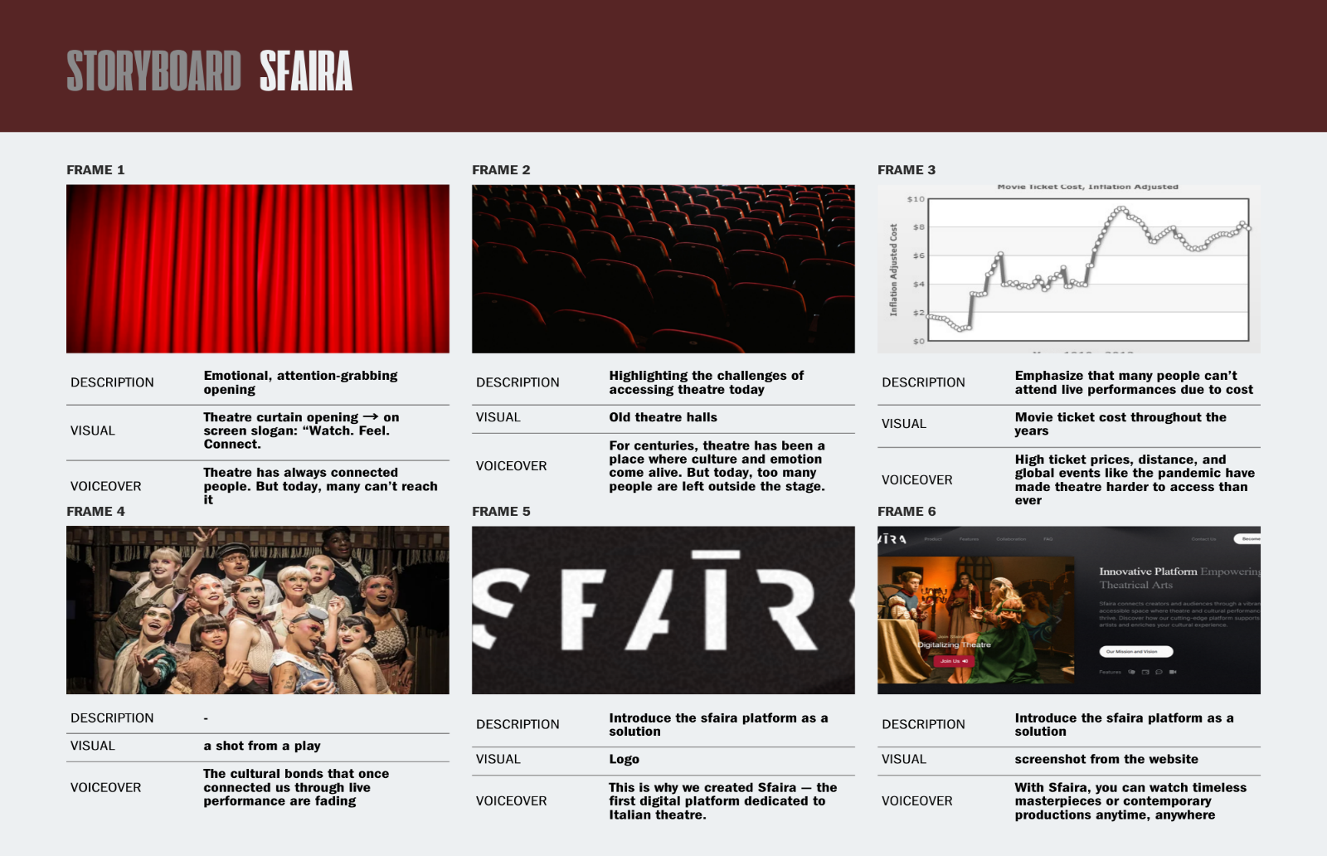

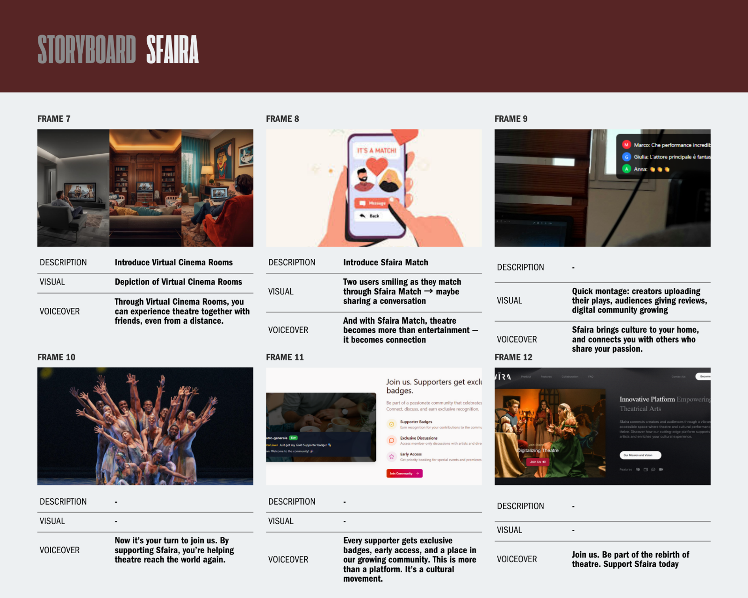

#### Sfaira Campaign Video Outline

|  |  |  |  |
| --- | --- | --- | --- |
| **Time** | **Description** | **Visuals** | **Voiceover / Text** |
| 0:00–0:20 | Emotional opening, create curiosity | Theatre curtain closing/opening, empty stage → slogan on screen *“Watch. Feel. Connect.”* | *“Theatre has always connected people. But today, many can’t reach it.”* |
| 0:20–0:30 | Show loss of access | Old theatre halls with closed doors, dim lights | *“For centuries, theatre has been a place where culture and emotion come alive.”* |
| 0:30–0:50 | Emphasize the problem | Empty seats, spotlight fading, a person at home holding an unused theatre ticket | *“But now, ticket prices, distance, and global events like the pandemic have left too many outside the stage.”* |
| 0:50–1:00 | Transition to solution | Curtains reopen, laptop streaming a play | *“This is why we created Sfaira.”* |
| 1:00–1:20 | Introduce streaming | Split-screen: people in different homes watching the same play | *“The first digital platform bringing Italian theatre to the world — streaming anytime, anywhere.”* |
| 1:20–1:30 | Highlight community feature | Chat bubbles, emojis popping during a play (Virtual Cinema Room) | *“Experience theatre together with friends, even from a distance.”* |
| 1:30–1:40 | Highlight Sfaira Match | Two users connect through Sfaira Match → chat begins | *“With Sfaira Match, theatre becomes more than entertainment — it becomes connection.”* |
| 1:40–1:55 | Show perks of supporting | Montage: badges (Silver, Gold, Founder) glowing on screen | *“Supporters receive exclusive badges, early access, and recognition as part of our growing community.”* |
| 1:55–2:10 | Milestone Tracker reveal | Animated progress bar filling up → features unlocking | *“Every milestone brings us closer to unlocking new features and expanding the platform.”* |
| 2:10–2:20 | Founder Wall recognition | Names appearing on a digital Founder Wall | *“Your name will forever be part of the rebirth of digital theatre.”* |
| 2:20–2:30 | Strong call-to-action | Montage of happy viewers, Discord community, theatre streaming → final frame with logo + *Kickstarter/Indiegogo link* | *“Join us. Be part of the rebirth of theatre. Support Sfaira today.”* |

#### Campaign Visuals

Infographics

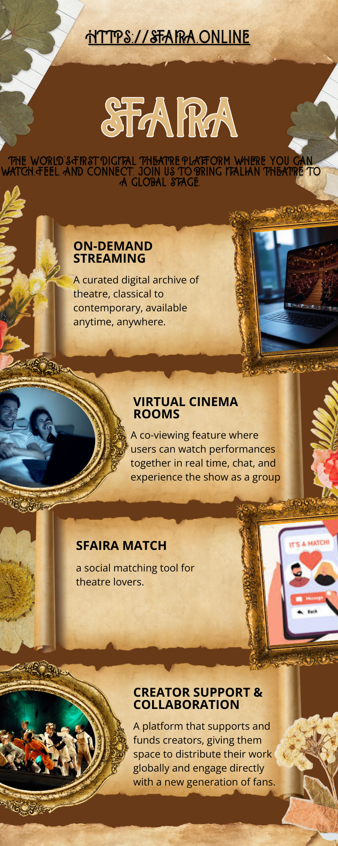

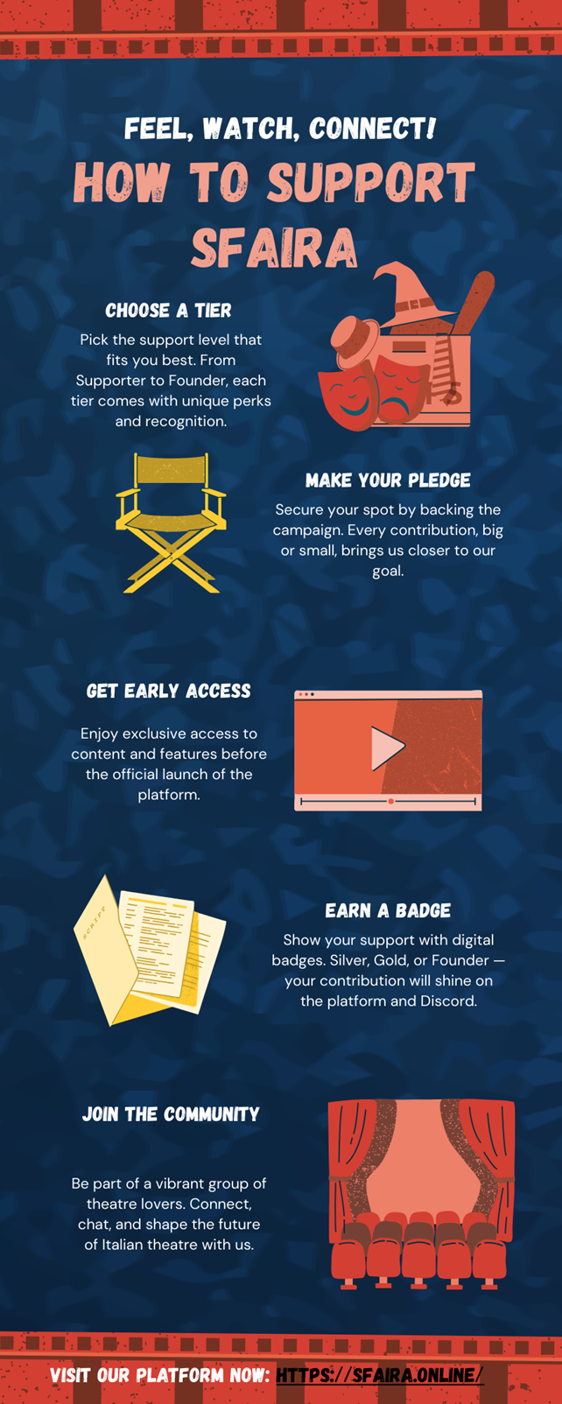

#### Mockups

*Homescreen*

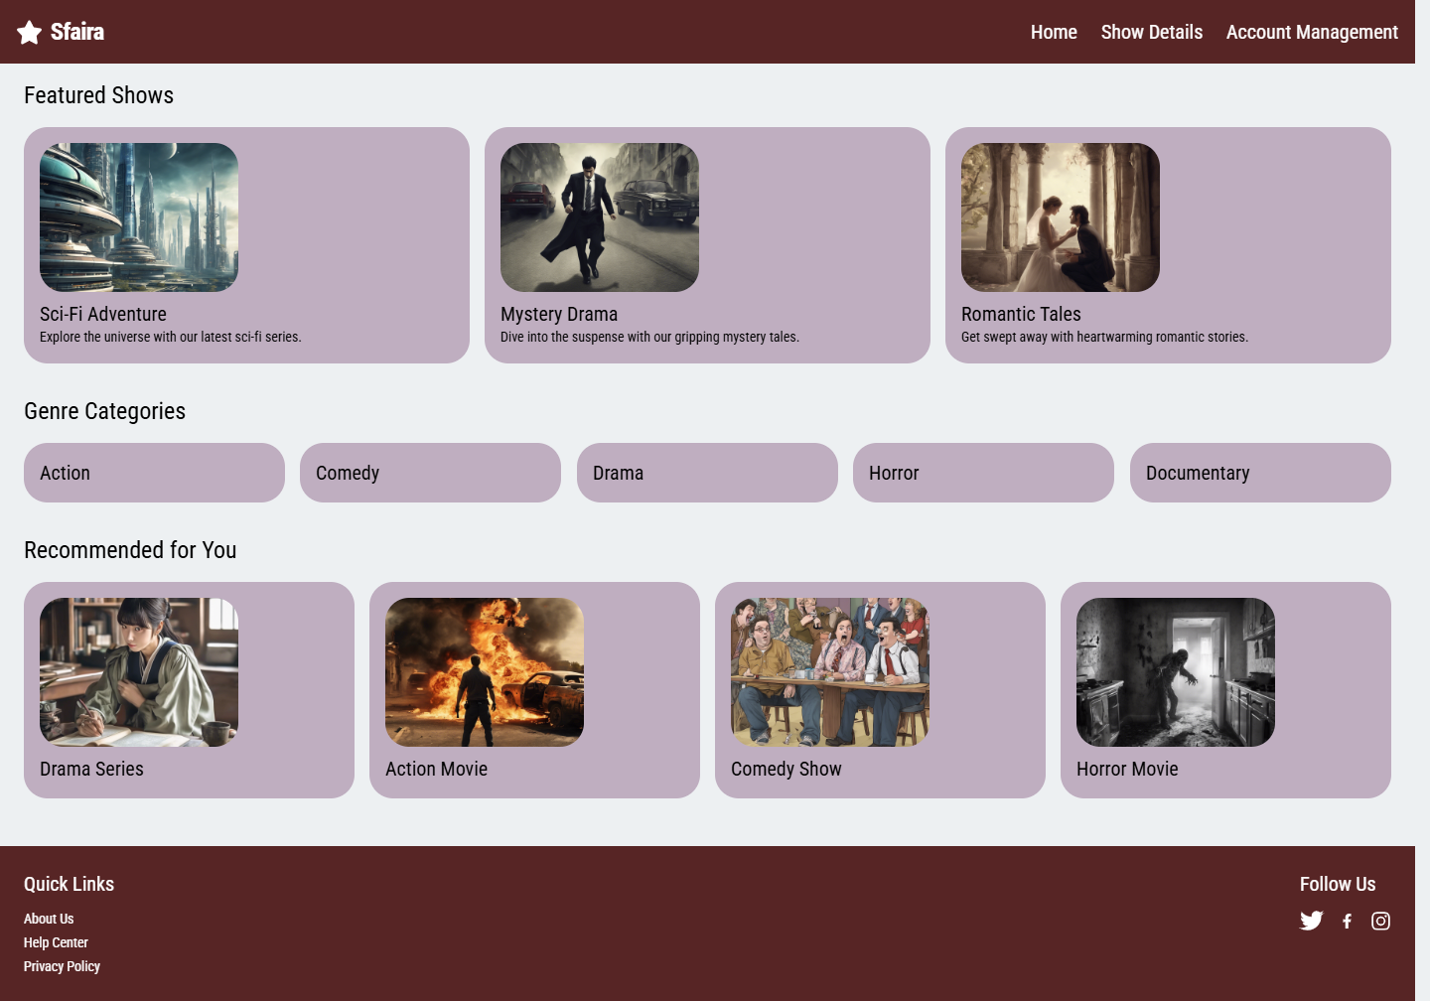

*When you click a play*

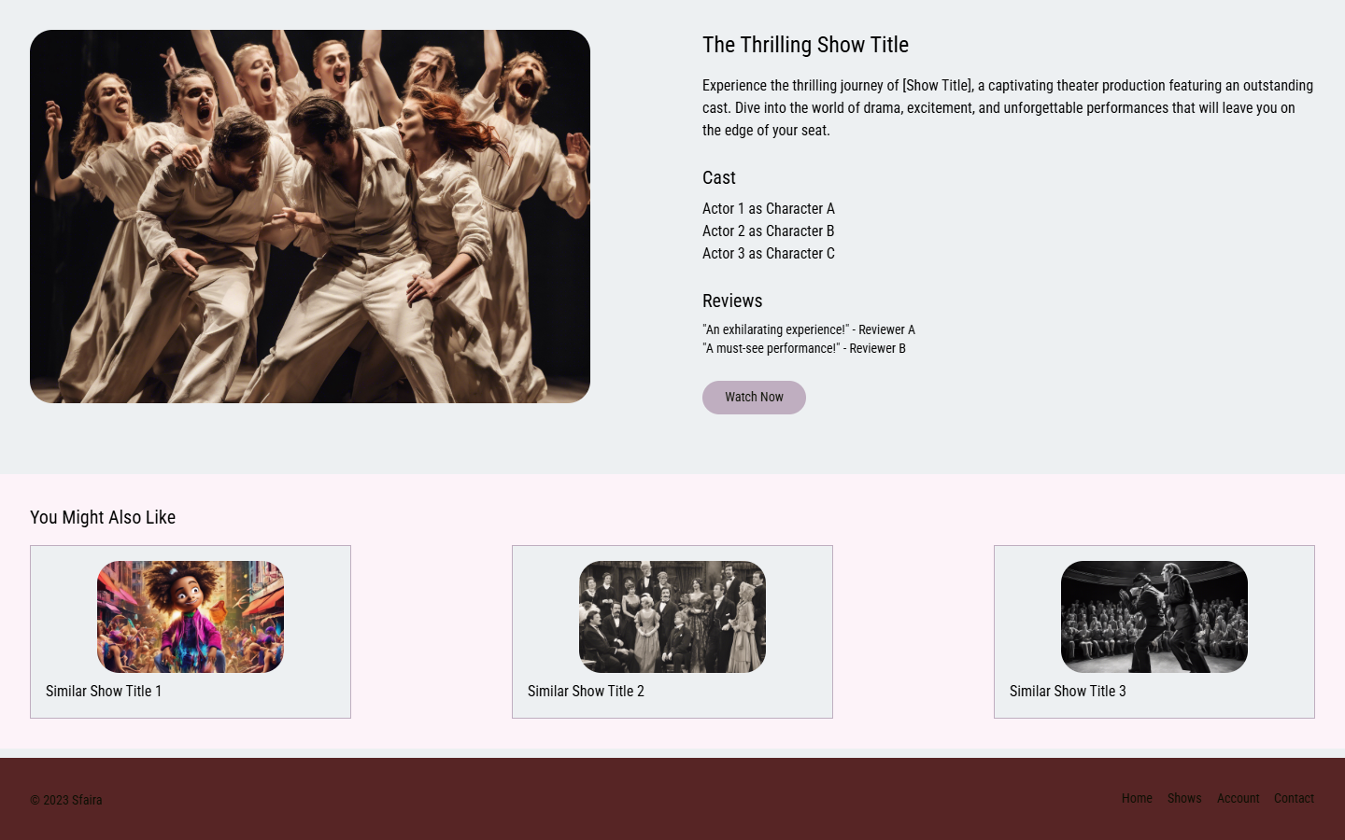

*Profile*

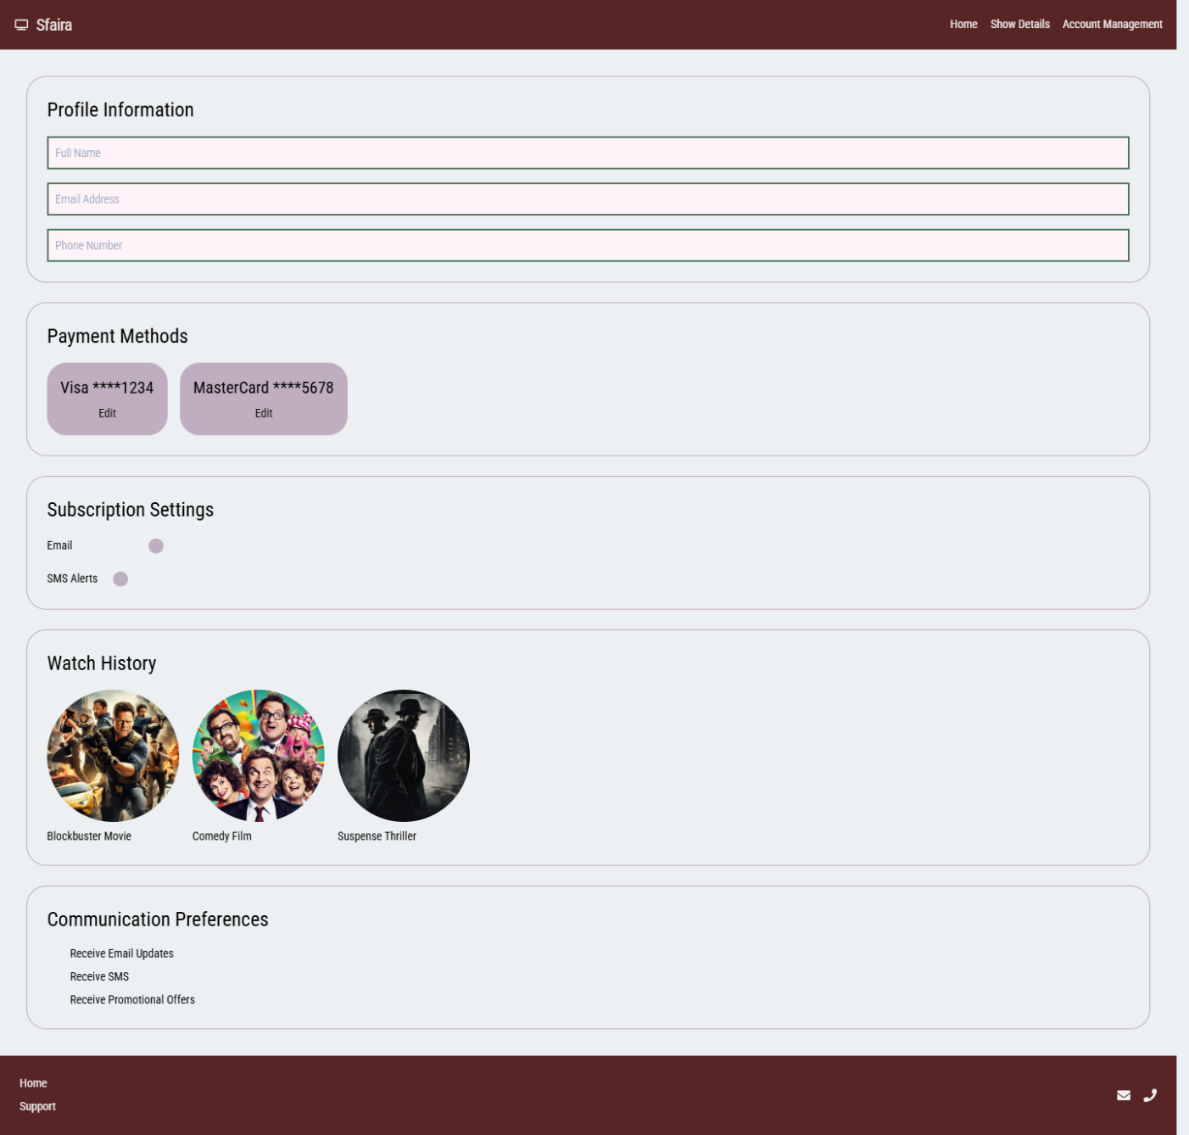

#### Short outreach email template

For the Influencers (Content Creators)

**Subject:** Let’s bring Italian theatre to the digital stage together 🎬✨

**Body:**  
Hi [Name],

I’m reaching out on behalf of **Sfaira**, a new digital platform dedicated to streaming Italian theatre worldwide. Our mission is to make theatre more accessible while building a vibrant online community.

We’re currently preparing for our crowdfunding campaign and would love to collaborate with inspiring creators like you. Whether it’s through sharing our story, co-creating content, or simply joining our community, your voice can make a real impact.

Would you be open to a quick chat about how we could work together?

Best regards,  
Sfaira Marketing Team

For the Creators / Theatre Groups (Theatre Organizations etc.)

**Subject:** Opportunity to showcase your theatre on Sfaira 🎭

**Body:**  
Dear [Name],

I’m part of the team behind **Sfaira**, a new digital stage for Italian theatre. We are building a platform that streams theatre performances worldwide and creates new opportunities for creators to reach audiences they could not otherwise access.

We’ve noticed your work on [Platform / Project Name] and would love to explore whether your performances could be hosted on Sfaira. Our goal is to support theatre groups by giving them visibility, revenue opportunities, and a global audience.

Would you be interested in learning more about how Sfaira could feature your work?

Warm regards,  
Sfaira Marketing Team